**Adapter Utility User Guide**

**Purpose:**

The File Adapter Utility is used to generate the File Adapter configuration with Read or Write schemas for a given SAP parsed IDOC structure. We can use this utility to generate either new configuration or we can add new schemas to existing File Adapter Configuration. This is property driven utility.

**Input File:**

SAP Parsed IDOC file.



**Properties in Configuration file**

**Segment_Prefix :** This is optional parameter. Thevalue of this parameter will be appended as prefix to each segment in the generated schema file.It takes alphanumeric characters along with underscore.

**isReadSchema** : This is required parameter. It takes values- true or false. If this value is set to true, Read Schema will be created otherwise, write schema will be created.

**delimitedFile :** This is a required parameter and is used to decide if the file to be read/written is positional or delimited. If the file to be read/written using the generated schema is delimited file, set this field’s value to true and if the file is positional, set this value to false.

**delimiter:** This will be required when delimitedFile parameter is set to true. The value of this parameter will be used as delimiter in generated schema.

**parsediDocPath**: The full path along with the file name of the Parsed IDOC file as provided by SAP System.

**metadataFilePath**: The complete path of the file where the metadata file has to be created. Metadata file is an intermediate file created by this utility. It has information from SAP parsed IDoc file in another format delimited by hyphen”-“. The SAP Parsed IDOC contains information like field/segment name, type, length, position, first character, last character each on a different line. The metadataGenerator combines these field values into one hyphen separated line for each field or segment name.

**SchemaName**: This is mandatory parameter. It is the name of the schema to be created.

**AdapterTemplate**: It contains the default adapter Template file path along with the name. Don’t change this path. This parameter will be used when generating new adapter configuration.

**AdapterConfigFileName:**  This is a mandatory parameter. It contains name of the adapter configuration to be created for new adapter configurations. If we are updating existing adapter configuration, please specify the existing Adapter Configuration name (before extension .adfiles).

**AdapterConfigPath:** It is mandatory field. It contains the path where the adapter configuration files will be generated.This is set to current directory by default. Within this directory, native and wire directory has to be created to place native and wire schemas.

**CreateNewAdapterConfig:** This is a mandatory field. If this value is set to true, new adapter configuration will be created. If this value is set to false, existing adapter configurations will be updated. The existing adapter configurations are provided by the properties given below.

**ExistingAdapterConfigFile:** This is mandatory for updating existing adapter configuration. It contains file name along with the path of existing adapter configuration file (file with extension .adfile).

**ExistingNativeSchema:** This is mandatory for updating existing adapter configuration. It contains file name along with the path of existing adapter native schema file (file with extension .aeschema).

**ExistingWiredSchema:** This is mandatory for updating existing adapter configuration. It contains file name along with the path of existing adapter wire schema file (file with extension .aeschema).

**Steps to Create/Update Adapter Configuration**

1. Please get the parsed IDOC file from SAP System.
2. Set the properties appropriately as described above in property configuration file.
3. Run the metadataGenerator.java and then schemaGenerator.java using the command utility provided.
4. Copy the newly generated adapter configuration files including native and wire schemas and place them in your project folder in respective location from back end.

ProjectFolder\< Folder for file Adapter Configurations>\ 🡨 Copy .adfile here.

ProjectFolder\AESchemas\ae\native\ 🡨 Copy native schema here

ProjectFolder\AESchemas\ae\wire\ 🡨 Copy wire schema here

If it is newly created adapter configurations, please copy the file operation.aeschema provided in file adapter utility folder to the directory ProjectFolder\AESchemas/ae/FileAdapter folder.

**Creating New Adapter Configuration for Read schema to read files containing Positional records**

1. The parsed IDOC from SAP System is provided below.



1. The property file is updated as shown below.



1. After running the metadataGenerator.java, the below metadata file is generated.



After running schemaGenerator.java, the below files are generated in the path provided in properties file.

AdapterConfiguration file



Native schema file



Wire schema file



1. After copying the Adapter Configuration file, operation.aeschema, native and wired schema files to their respective locations, the adapter schema looks as given below.

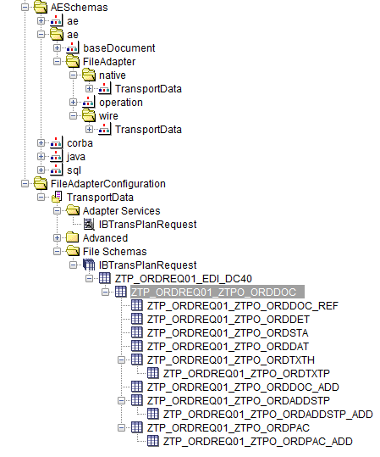

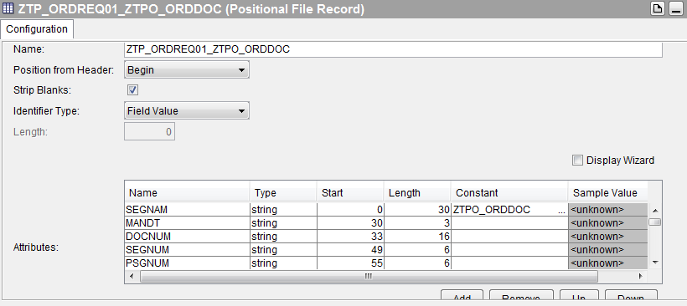

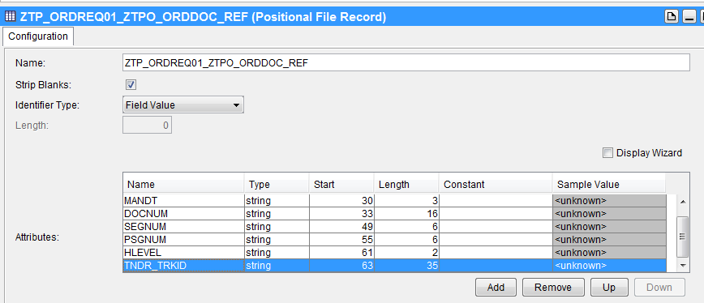

**Creating New Adapter Configuration for Read schema to read files containing Delimited records**

1. The parsed IDOC from SAP System is provided below.



1. The property file is updated as shown below.



1. After running the metadataGenerator.java, the below metadata file is generated.



After running schemaGenerator.java, the below files are generated in the path provided in properties file.

AdapterConfiguration file



Native Schema file



Wire Schema file



1. After copying the Adapter Configuration file, operation.aeschema, native and wired schema files to their respective locations, the adapter schema looks as given below.

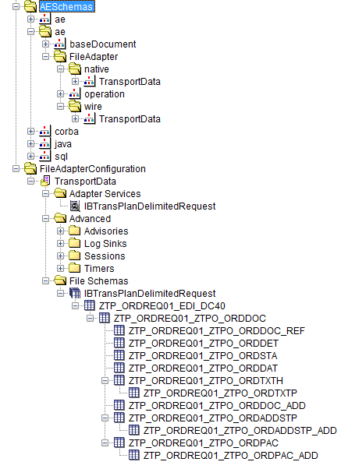

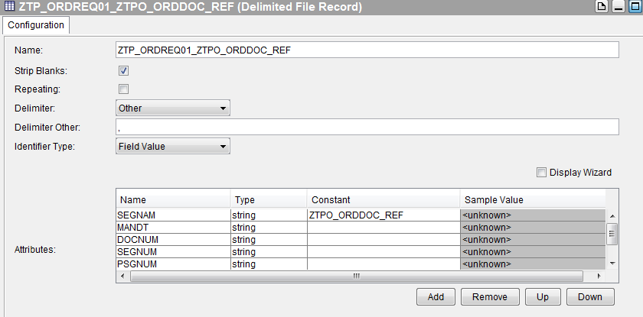

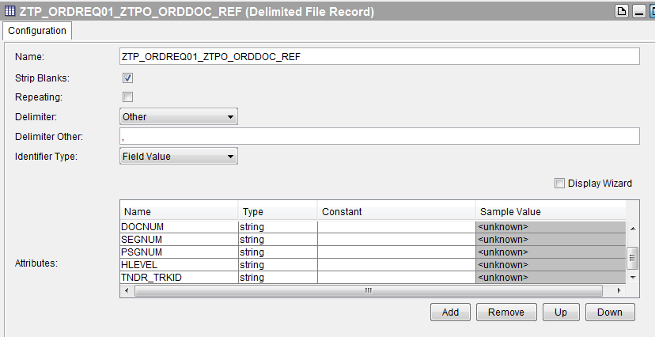

**Creating New Adapter Configuration for Write schema to write files containing Positional records**

1. The parsed IDOC from SAP System is provided below.



1. The property file is updated as shown below.



1. After running the metadataGenerator.java, the below metadata file is generated.



After running schemaGenerator.java, the below files are generated in the path provided in properties file.

AdapterConfiguration file



Native schema



Wire schema



1. After copying the Adapter Configuration file, operation.aeschema, native and wired schema files to their respective locations, the adapter schema looks as given below.

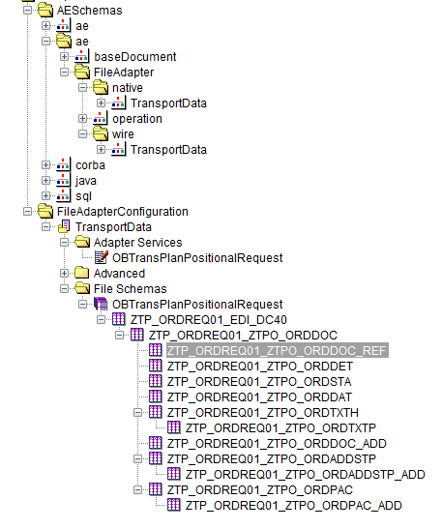

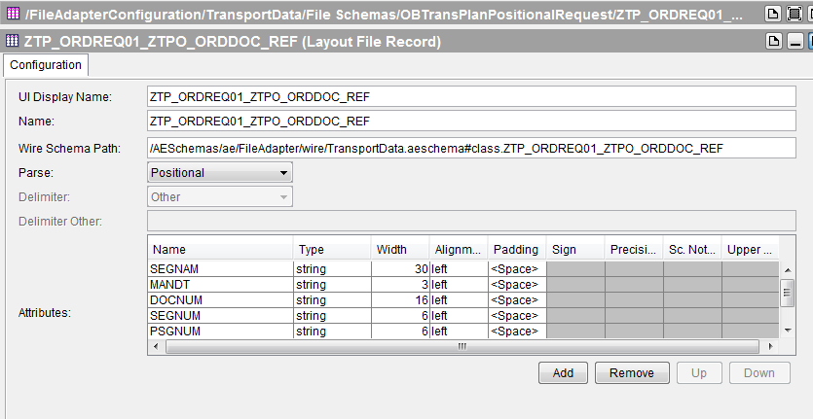

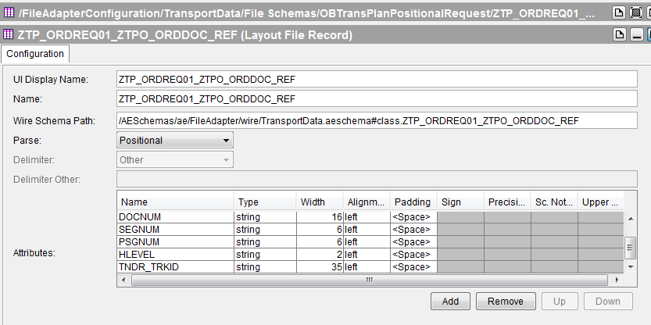

**Creating New Adapter Configuration for Write schema to write files containing Delimited records**

1. The parsed IDOC from SAP System is provided below.



1. The property file is updated as shown below.



1. After running the metadataGenerator.java, the below metadata file is generated.



After running schemaGenerator.java, the below files are generated in the path provided in properties file.

AdapterConfiguration file



Native Schema



Wire Schema



1. After copying the Adapter Configuration file, operation.aeschema, native and wired schema files to their respective locations, the adapter schema looks as given below.

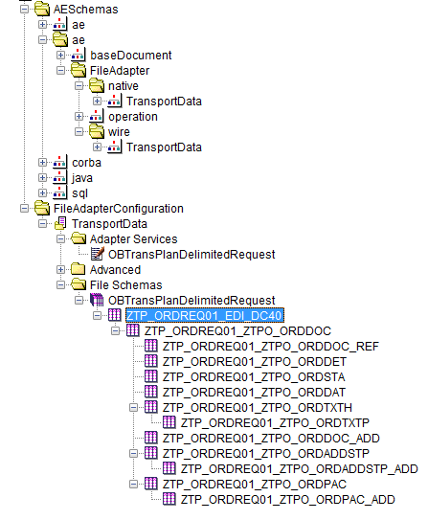

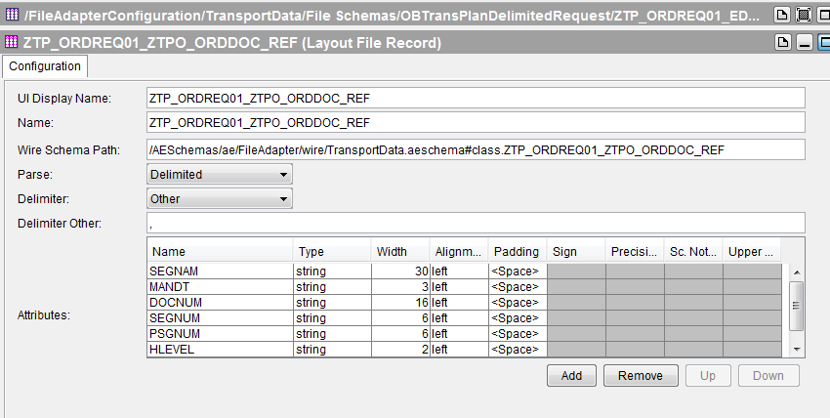

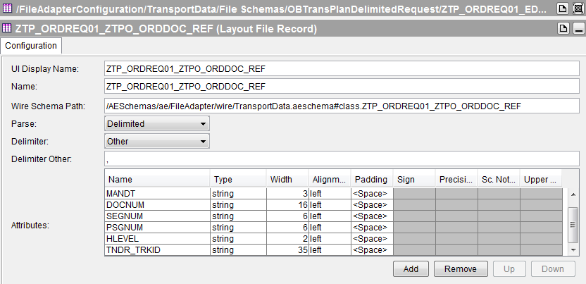

**Updating exiting Adapter Configuration- Add Read schema to read files containing Positional records**

Suppose we are using an adapter configuration having write schema to write positional records. We are now trying to update this configuration, to add Read schema to read files containing Positional Records.

1. The parsed IDOC from SAP System is provided below.



1. The property file is updated as shown below.



1. After running the metadataGenerator.java, the below metadata file is generated.



After running schemaGenerator.java, the below files are generated in the path provided in properties file.

Adapter Configuration



Native schema



Wire Schema



1. After copying the Adapter Configuration file, operation.aeschema, native and wired schema files to their respective locations, the adapter schema looks as given below.

The Read Schema is appended at the end of existing schemas as shown below.

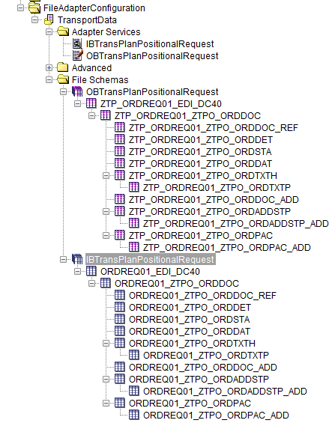

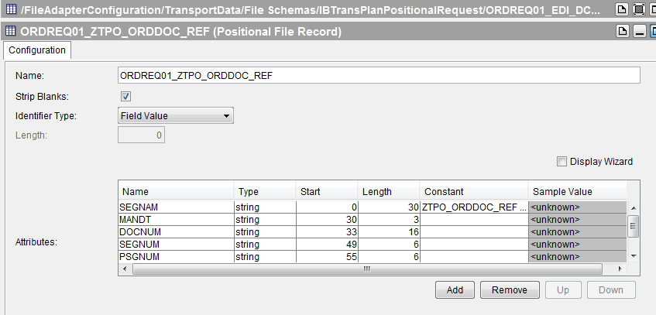

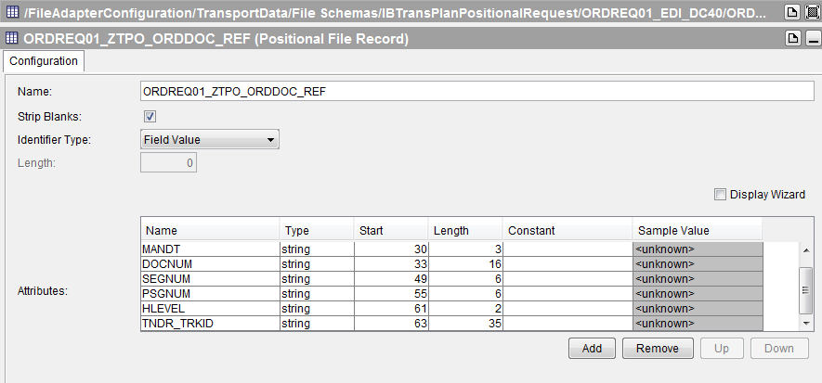

**Updating exiting Adapter Configuration- Add Read schema to read files containing Delimited records**

Suppose we are using an adapter configuration having write schema to write delimited records. We are now trying to update this configuration by adding Read schema to read files containing Delimited records.

1. The parsed IDOC from SAP System is provided below.



1. The property file is updated as shown below.



1. After running the metadataGenerator.java, the below metadata file is generated.



After running schemaGenerator.java, the below files are generated in the path provided in properties file.

Adapter Configuration



Native schema



Wire Schema



1. After copying the Adapter Configuration file, operation.aeschema, native and wired schema files to their respective locations, the adapter schema looks as given below.

The Read Schema is appended at the end of existing schemas as shown below.

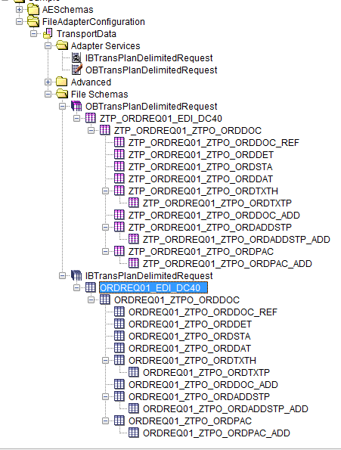

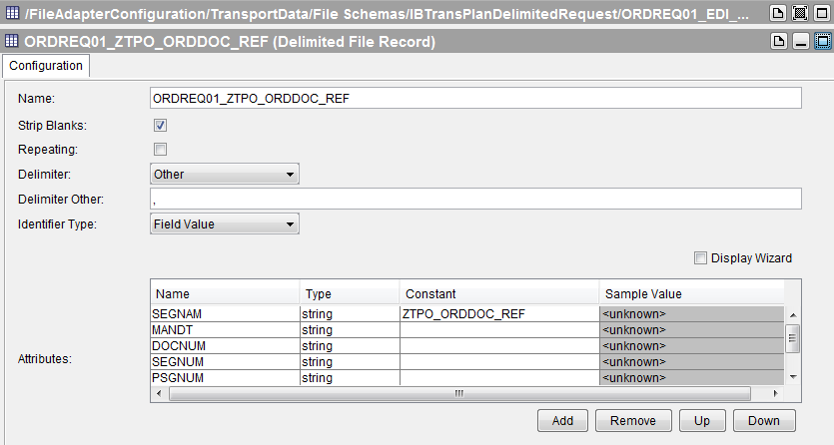

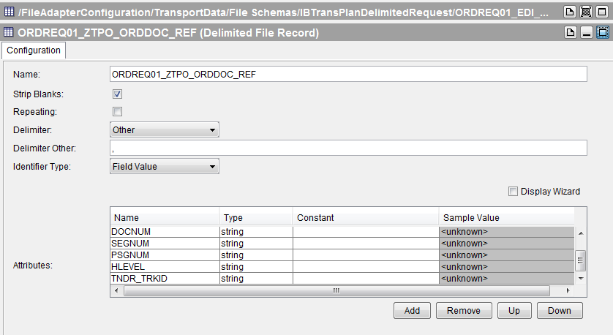

**Updating exiting Adapter Configuration- Add Write schema to write files containing Positional records**

Suppose we are using an adapter configuration having read schema to read positional records. We are now trying to update this configuration, to add Write schema to write files containing Positional Records.

1. The parsed IDOC from SAP System is provided below.



1. The property file is updated as shown below.



1. After running the metadataGenerator.java, the below metadata file is generated.



After running schemaGenerator.java, the below files are generated in the path provided in properties file.

Adapter Configuration



Native schema



Wire Schema



1. After copying the Adapter Configuration file, operation.aeschema, native and wired schema files to their respective locations, the adapter schema looks as given below.

The Write Schema is appended at the end of existing schemas as shown below.

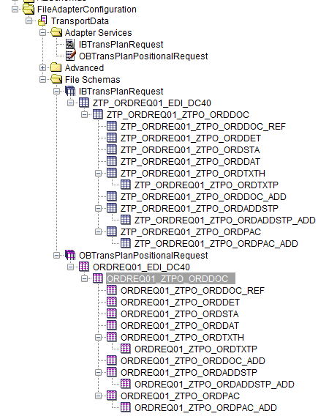

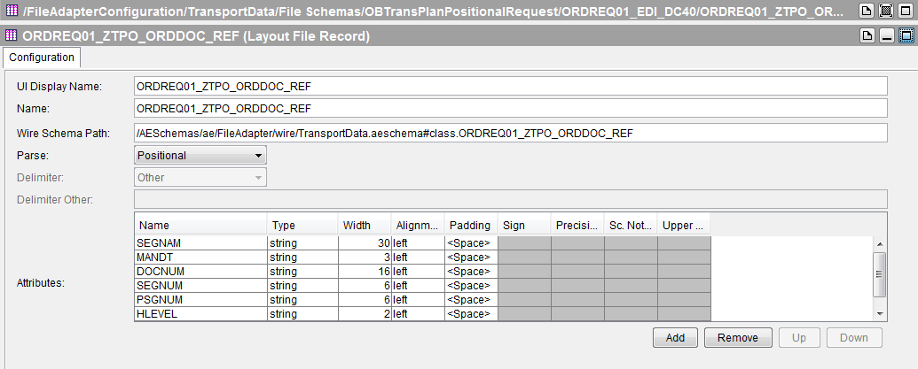

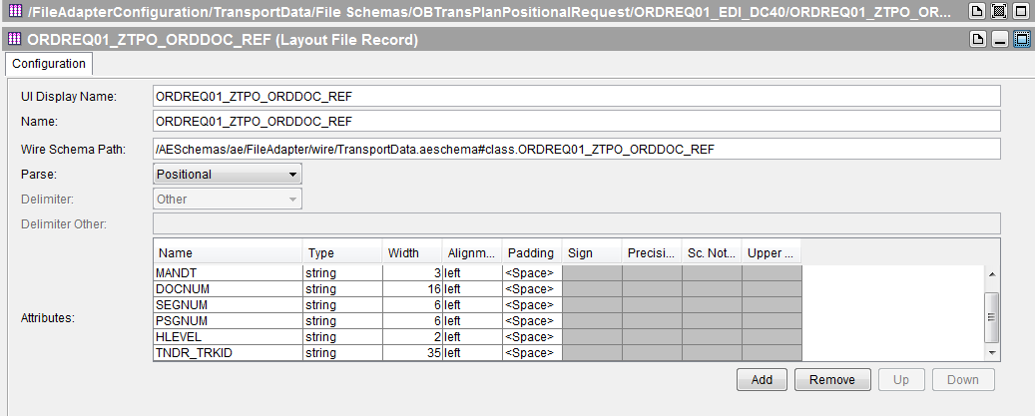

**Updating exiting Adapter Configuration- Add Write schema to write files containing delimited records**

Suppose we are using an adapter configuration having read schema to read delimited records. We are now trying to update this configuration, to add Write schema to write files containing Delimited Records.

1. The parsed IDOC from SAP System is provided below.



1. The property file is updated as shown below.



1. After running the metadataGenerator.java, the below metadata file is generated.



After running schemaGenerator.java, the below files are generated in the path provided in properties file.

Adapter Configuration



Native schema



Wire Schema



1. After copying the Adapter Configuration file, operation.aeschema, native and wired schema files to their respective locations, the adapter schema looks as given below.

The Write Schema is appended at the end of existing schemas as shown below.

